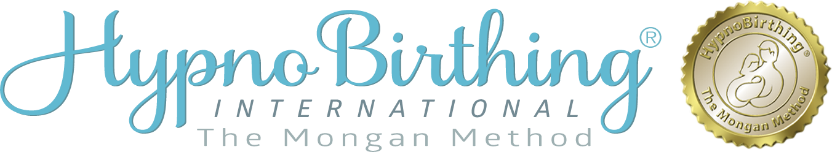

HypnoBirthing Educator Training Registration
Please complete the form to register for the training.

First Name: Last Name:

Address:

Suburb: Province Postal Code

Phone No: Mobile No:

Email:

Current Profession: If a midwife, which hospital or group
practice are you currently working with?

Training:

Course requirements to become a Certified HypnoBirthing® Educator:
Introduction to Hypnosis (1.5 Days)
Educator Training (2.5 Days)
Birthing Basics (Home Study)
Reviews & Case Study

GET THE EARLYBIRD PRICE –1,495 CAD$ Full payment date:

Payment by E-Transfer to: ilona@hypnobirthingcanada.com
Or PayPal if paid by credit card or other.

Full 4 Day Educator Training): Birthing Basics Home Study 245 CAD$
Includes Intro to Hypnosis 1.5 Days

All candidates are required to complete the full 4-day face to face training or Zoom when available.
If you are a midwife or Doula you will not be required to complete the Birthing Basics Home Study.

After March 2nd 2022 the full tuition will be : 1,695 CAD$ Full payment date:

